Computer Networks (Question Pool)
- Compare OSI Model and TCP/IP Model. Provide at least four key differences.
- List any four components of a computer network and briefly explain their functions.
- What is the difference between twisted pair cables and fiber optic cable?
- Explain the different modes of data communication: simplex, half-duplex, and full duplex.
- How does classless addressing solve the limitations of classful addressing?
- Comparison of Classful and Classless Addressing.
- Explain the role of subnetting in IPv4 and how it differs in IPv6.
- Compare Connection oriented and connectionless service?
- Explain different types of network topologies with diagrams.
- State the difference between congestion control and flow control?
- Explain three steps of the TCP three-way handshake.
- Explain ARP and RARP.
- Explain how NAT works and describe its types with suitable examples
- What is framing and its types?
- Explain each component of TCP Header and UDP Header?
- Describe the working of HTTP.
- Explain how the Domain Name System (DNS) works?
- What are encoding violations in framing?
- What are the functions of SMTP?
- What is IP fragmentation.
- Describe the working of SMTP and its role in sending emails.
- Explain how ICMP works. Describe the format of ICMP messages and their role in error reporting and diagnostics.
- Name the routing protocol in which each node stores the topology map of the entire network. Also compare it with distance vector routing protocol?
- Create four different scenarios of email architecture and explain them briefly. Also, explain the role of Message Transfer Agent (MTA).
- Classify differences in details between Leaky Bucket and Token Bucket?
- Explain the TCP three-way handshake process used to establish a connection between a client and a server. Include the sequence of control messages exchanged, the purpose of each step, and how sequence numbers are determined and used during this process.
- Describe the four-step process used to terminate a TCP connection. Explain the sequence of FIN and ACK messages exchanged between the client and server and discuss why a four-step process is necessary instead of a two-step process.
- A TCP connection experiences packet loss, triggering congestion control mechanisms. Explain the following algorithms used by TCP to manage congestion: (a) Slow Start, b) Congestion Avoidance, c) Fast Retransmit, d) Fast Recovery e) Additive Increase/Multiplicative Decrease (AIMD)
- A 7-bit message 1110001 with a parity bit 1 (full 8-bit word: 11110001) is transmitted. Using even parity, determine if the message is correct or incorrect. If the received codeword is 110101110, check if an error has occurred.
- The transmitted 7-bit message is 1001010 and the parity bit is 0 (full 8-bit word: 01001010). If odd parity is used, determine whether the message is correct or incorrect.
- A sender wants to transmit a 7-bit data sequence 11010111 using Cyclic Redundancy Check (CRC) for error detection. The generator polynomial used is 1011 (4-bit long). (a)Perform CRC encoding by determining the remainder when the given data 11010111 is divided by 1011 using binary division. (b) Find the transmitted codeword (data + remainder).(c) If the receiver gets the transmitted codeword without modification, (d) what should the remainder be after checking for errors?
- A sender sends packets 0 through 5. It receives an ACK with ackNo = 2. What does this mean under the Go-Back-N and Selective Reject protocols?
- A 6-bit dataword 110110 is sent using CRC with the generator polynomial 1011. (a) What is the transmitted codeword? (b) If the receiver receives 110110011, check if there was an error during transmission.
- Describe the working of the Link-State Routing algorithm. Explain how Dijkstra’s algorithm is used to calculate the shortest path.
- Nodes: V1, V2, V3, V4, V5, V6, Use Dijkstra's Algorithm starting from node V1 to find the shortest path to all nodes.

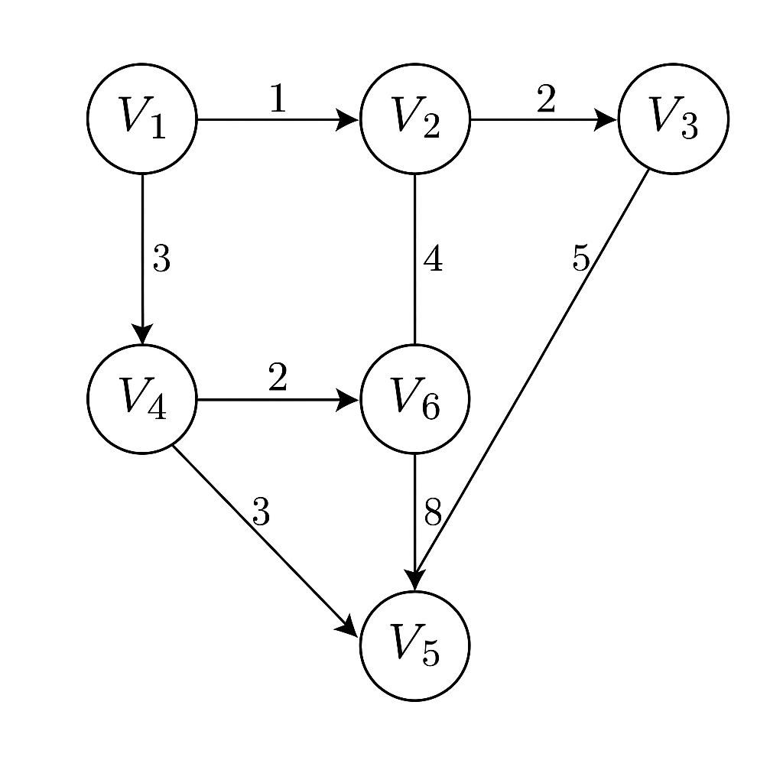
- Consider the following Network directed weighted graph with 5 Nodes (A, B, C, D, E) and the given edges: Using Bellman-Ford Algorithm, find the shortest distance from the source node A to all other nodes. Show all the steps of the algorithm, including the initialization and the result after each iteration of edge relaxation. Also, indicate if the Network graph contains any negative weight cycle.
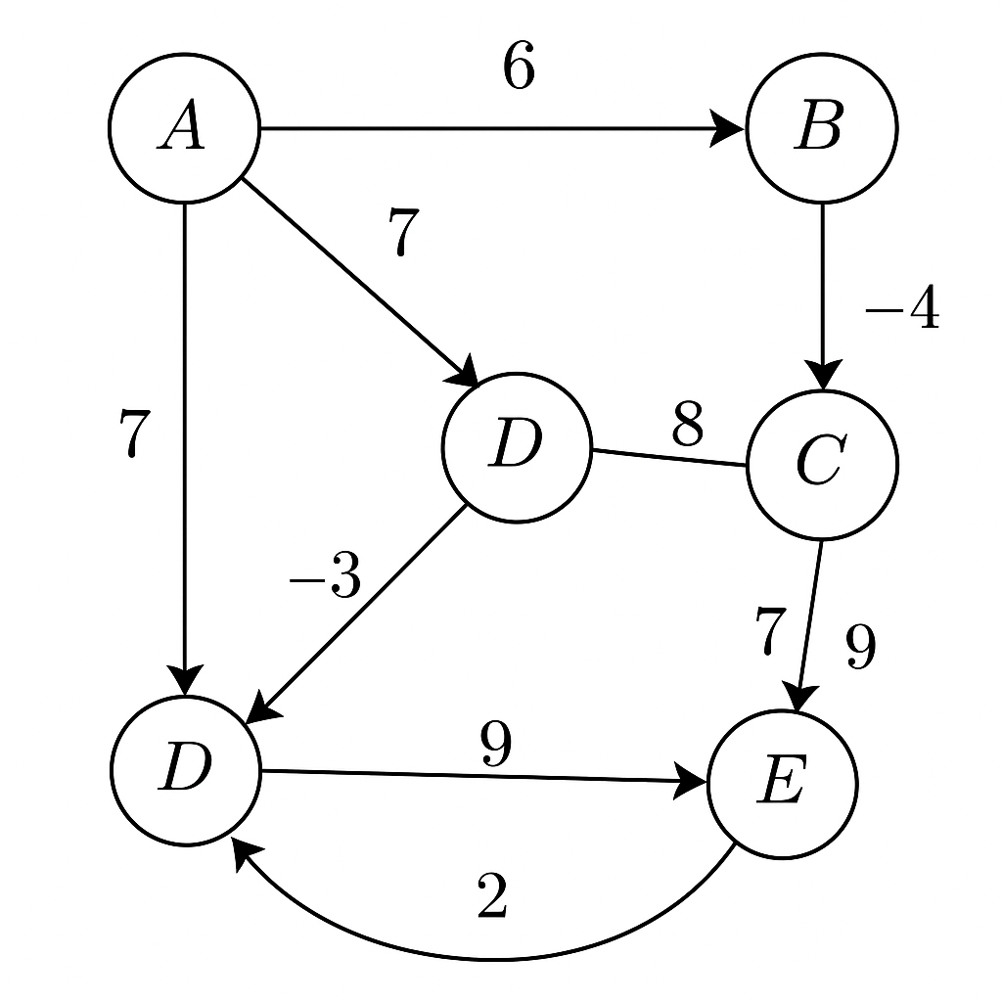
- Consider the following weighted, directed graph with 6 nodes: A, B, C, D, E, F. The Network graph contains the following edges and their respective weights: Using Dijkstra's Algorithm, find the shortest path from the source node A to all other nodes in the Network.
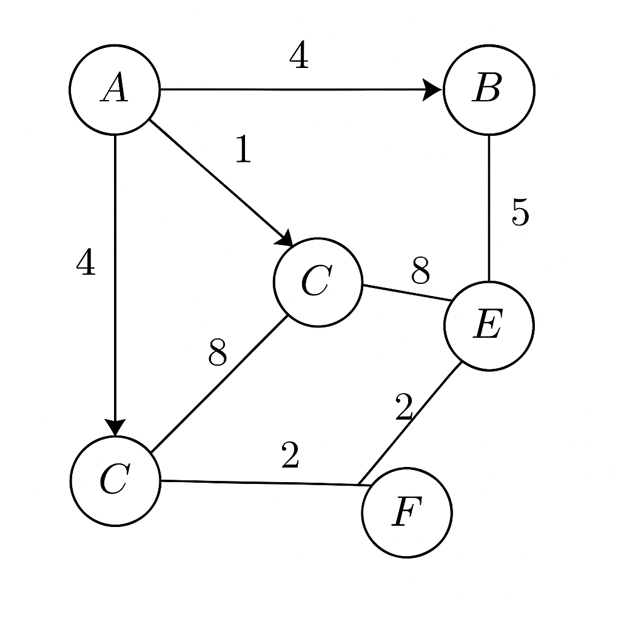

- Using the Bellman-Ford algorithm, find the shortest path from source node A to all other nodes in the following graph with positive edge weights:
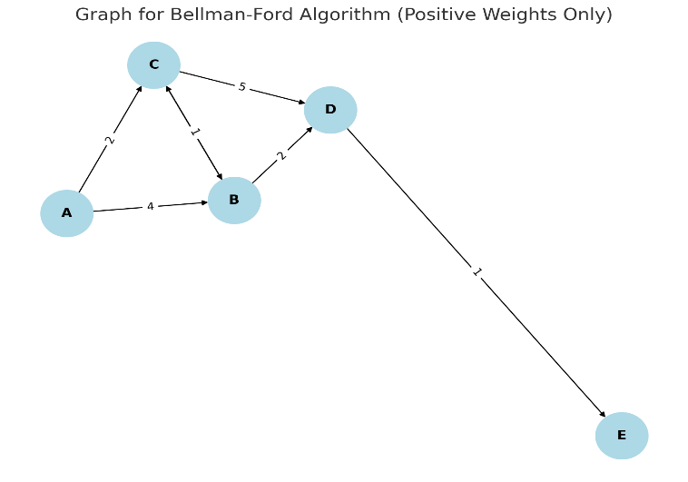
- During a transmission of 2,000,000 bits, 400 bits were received incorrectly. What is the BER?
- Station A has to send 12 packets to station B using Go-Back-N ARQ with a window size of 4.If every 4th packet transmitted is lost, and ACKs are always received correctly, How many total packets will A transmit?
- You have the network 192.168.100.0/24. Divide it into 8 equal subnets. (a) List all subnet addresses.(b)What will be the new subnet mask? (c)What are the first and last usable IPs in each subnet?
- Given the network 192.168.5.0/24, split it into 4 equal subnets. (a)List the subnet addresses. (b)Determine the new subnet mask. (c) Give the usable IP range in each subnet.

- Determine the network address for the IP address 10.0.15.32 and subnet mask 255.255.240.0.
- Calculating the Number of Subnets and Hosts: A company has been assigned the network 192.168.1.0/24. The administrator wants to create 6 subnets. (a) What subnet mask should be used? (b) How many usable hosts will each subnet have? (c) What are the first and last IP addresses for the first subnet? write the answer and explanation
- If the bandwidth of a channel is 2 Mbps and a file of 8 MB needs to be transferred,
how much time will it take?
- How much data (in bits) can be transmitted over a 1.5 Mbps connection in 10 seconds?
- A file of 40 Megabits needs to be sent, If the channel bandwidth is 4 Mbps, how long will the transmission take?
- Given the IP address 172.16.10.50 and a subnet mask of 255.255.0.0, determine the network and host portions.
- You are assigned the network 172.16.0.0/24. Divide this into 8 equal subnets. (a)List the subnet addresses. (b)What is the new subnet mask? (c)Provide the usable IP ranges for each subnet.
- Assume that your are a network engineering and you are given the following IP blocks: 192.168.10.0/24 (subnetting task) and 172.16.0.0/16 and 172.16.1.0/16 (supernetting task):-A company needs 5 departments, each with at least 25 hosts. From the given block 192.168.10.0/24, analyze and determine: (a)The new subnet mask (b)The IP ranges for each subnet (first and last valid IP).

